**Statement of Commitment**

I acknowledge the significant responsibility of my role as a **GIS specialist and data analyst** in the consultancy service to “Climate Vulnerability and Risk Assessment of Local Governments”. I am fully committed to this endeavor and pledge to uphold the following:

* I will contribute my expertise to ensure high-quality work and timely completion of the project.
* I commit to being available throughout the project period and to collaborate with the team leader and members.
* I will actively participate in all requests for assistance and ensure responsive communication.
* Recognizing the potential for change, I vow to remain adaptable and flexible, adjusting my approach as needed.

I confirm my agreement with this Letter of Commitment and am eager to support the consultancy service.

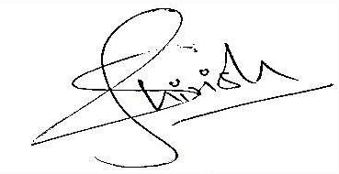

**Signature:** _____________________ **Date:** March 3, 2024

**Print name:**